

**Duration: (60 Hours): 45 Days**

**Timing: 9.30 to 11 am: Mon to Fri**

**Fee: Rs 5,000**

* **Python Faculty : Mr.Karthik, Consultant**

**Every WEEK NEW BATCH Commences**

* **100% JOB ORIENTED Course, Can Attend Online or Classroom**
* **Every Class contains step by step notes with Screenshots**
* **Will provide Recording Sessions for class Revision**

**Online Gotomeeting ID:**

[**https://global.gotomeeting.com/join/396530733**](https://global.gotomeeting.com/join/396530733)

**http://statisticstimes.com/tech/top-computer-languages.php**

**https://www.indeed.com/jobtrends/q-java-q-c%23-q-php-q-python.html**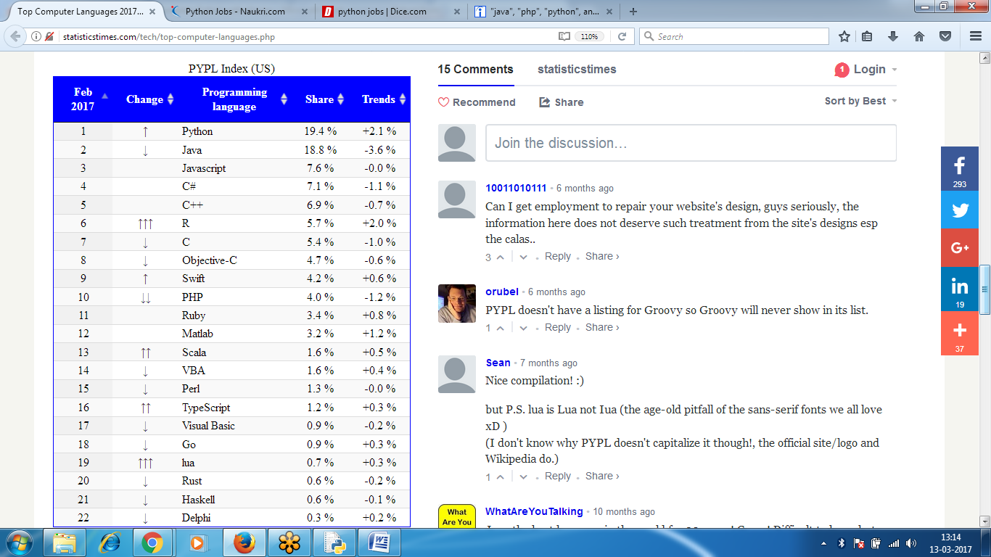`

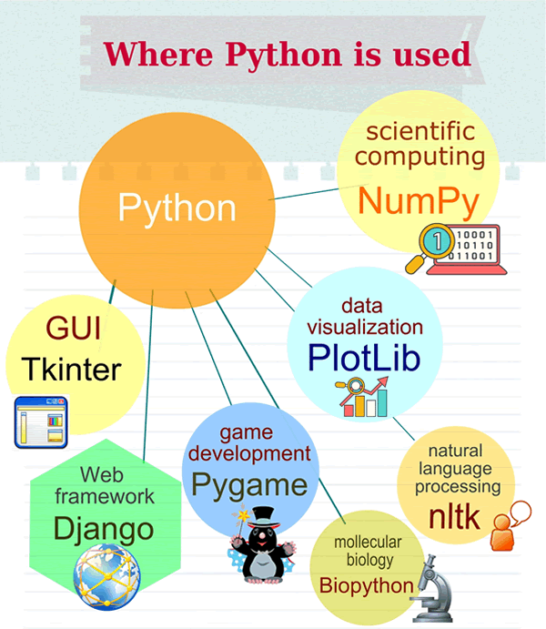

**Web Technology uses PYTHON with django**

**Mobile Apps uses PYTHON with FLASK**

**Big Data** **Hadoop** uses **PYTHON**

**Data Science** Analytics uses **PYTHON**

**Amazon Web Services** uses **PYTHON**

**Automation Tools DevOps** uses **PYTHON**

**Reporting Tableau** uses **PYTHON**

**Scripting** and **GUI Apps** Uses **PYTHON**

**Scientific Applications** uses **PYTHON with Numpy, Scipy**

**Gaming, Networking, Embedded Systems, AI**

**Python Training**

**Duration: 60 Hours**

**1 Python Programming Basics::**

* Demo: Evolution and Top Computer Languages, Why step into Python, Python Features,

Why Python is Year-on-Year Demand, Python Frameworks, Career Perspective in Python,

Job Opportunities in Python, Where Python is Used, Compare with Other Popular Languages

* Python.org, Python Installation & Introduction, What are Operators, Expressions, Data Types,

What are Variables and Rules, Statements, Python Shell, Program Execution, Python Editors?

Different types of Comments and Functions, Programming Rules

* Boolean Values, Data type Conversions, Flow Controls: If-else, If-elif-else, Assignment,

Augmented Operators, Multiple Assignment,

Progs: Biggest among 3 values, Given number is Even or Odd

* While Loop, For Loop, Range() function, Break, Continue, Pass, exit(), Infinite Loops

Progs: Print Sum of the Given Range of values, Print Given Range of Tables,

* Functions, Parameter types, Loops with Functions, Return statement, Optional and Named Parameters

Value and Reference Types, Local and Global Scope,

Progs: Find Given number is Prime or not

* **LIST, Tuple,** Type, Index, Slicing, Sub lists, Concatenation, Replication, in and not in, append,

index(), insert(), remove(), sort(), like, Mutable, Immutable, Converting types

**Dictionary** Type: keys(), values(), items(), get(), setdefault(),pprint(), pformat()

**2 Strings :: 2 Hours**

in String Literals, Escape Sequences, Raw strings, Triple Quotes, String Concatenation and Replica, Multiline Strings, Indexing and Slicing, in and not in Operators, String Methods, Regular Expressions, Pattern Matching, matching Multiple groups

**Methods:** lower(), upper(), title(), isalpha(), isdecimal(), isspace(), join(), split(), rjust(), ljust(), strip(), lstrip(),startswith(), endswith(), isdigit(), maketrans(), replace(), max(), min(), replace(), index(), rindex(), find(), rfind(), swapcase(), zfill() **Modules**: re, re.compile(), re.search(), format(),

**Programs:** User need to input until correct age and pwd, Program to find given string is Palindrome, To

Remove special Characters, Sort Words alphabetical order,

Print list of Unicode chars, Common Characters in strings,

Substring in a string, to check Phone Number string

**3 Files: 3 Hours**

Reading and Writing Files, Absolute and Relative path, file methods, Open files, Reading file, Writing or Appending data, Current Working directory, File path, checking path directory, store list of variables onto a file, Savings variables using Shelve module, Shutil module, Moving and Renaming Files and Folders, Permanently Deleting Folders and files, Command Line Arguments

**Methods:** open(), read(), Write(), close(), readLine(), seek(), tell(), makedirs(), getcwd(), getsize(), listdir(), isfile(), isdir(), pprint.pformat(), unlink(), rmdir(), rmtree(), os.walk(), shutil.copy(), copytree(), move(), read(n), readlines(), truncate(), argv

**Programs:** Reading data from a file character wise, Line by Line,

Accept String and write onto a file until user presses Enter key

Find Given String in a File, Program to Merge Name and body,

Display list of Folders, Filenames and File size, Restore data from drive

**4 Debugging: 2 Hours**

Types of Errors, Syntax and Logical Errors, Runtime Error, Exception Handling, Try-Except, Types of Exception, Multiple Exception block, Raise Exception, Handle Multiple Exceptions, IDLE’s Debugger,

Go, Step, Over, Out, Quit, Debugger Mode, Global and Local Variables, Debugging Mutable and Immutable Objects, Treace outs, Breakpoints,

**Programs:** How to handle Runtime Error, How to Handle Multiple Exceptions, Raising Exceptions

Program using Mutable and Immutable Objects

**5 Functions: 4 Hours**

Passing Parameter to a function, Default Parameters, Keyword Arguments, Recursive Functions, Inner Functions, Nested Functions, Typeless Functions, Returning Multiple Parameters, Mixed List and Dictionary Parameter Passing, Recursive Functions, ASCII and Unicode, Enumerate, Generator Function

Lambda Function, Collecting lambda functions in LIST,

**Methods:** ord(), chr(), Enumerate(), yield(), zip(), dir(), help(),

**Programs:** Difference between Normal and Lambda Function, Return List of elements which are divisible

by 2 using Lambda, collecting List of values in Lambda functions.

**6 Collections: 5 Hours**

List, Set, Tuple and Dictionary Data types, Mutable and Immutable Data Types, Working with References, List Concatenation and Replica, Nested List : List of Lists, Stack and Queue DS, List Slicing, Two and Three Dimensional Matrix, List Comprehension, Multiple Assignment, dictionary methods, pretty Printing, set, union, intersection, difference, Swapping values using or, xor

**Methods:** append(), extend(), insert(), remove(), clear(), index(), count(), sort(), copy(), reverse(), len(), list(), enumerate(), max(), min(), sum(), append and pop(), items(), values(), keys(), setdefault(),

**Programs:** Search a key in a List, Difference between Extend and Append in a List,

Intersect strings and List, Sort and Reverse using Lists and Tuples,

Using Nested Lists, Stack and Queue, Slice Insert and Delete,

Addition of two Matrices, Multiplication of Matrix, Transpose of a Matrix,

Fibonacci Series, Find number of Primes in a List, Building List Comprehension,

**8 Regular Expressions**

Jupyter (iPython) Notebooks, Regular Expression Basics , Regex Groups and the Pipe Character, Repetition in Regex Patterns and Greedy / Non greedy Matching, Regex Character Classes and the findall() Method , Regex Dot-Star and the Caret/Dollar Characters, Regex sub() Method and Verbose Mode, Regex

Program**:** A Phone and Email Scraper

**9 Python Decorators and Generators Python with Multithreading**

Multithreading, Subprocess, Multiprocessing, Multithreading, Concurrency and Parallelism, Creating and Joining Thread, Daemon and Canceling Threads, Asynchronous Programming, Critical Section and deadlock

Generator Syntax, Iteration and Generators, Creating Generators, Decorators Purpose, Simple Function Decorators, Classes as Decorators, Decorator Arguments

**10 OOPs:**

Procedure and Object Oriented, Code Reusability, Object Oriented Concepts, What is Class and Object, OOPS Features : Encapsulation, Polymorphism, Abstraction, Inheritance, Types of Inheritance, what is constructor, Passing parameters to Constructors, Initializing Objects, class method, static variable and methods

Programs: What is Class and Object, Declaring self, Multiple methods call thru object,

Fibonacci Series, Find number of Primes in a List, Building List Comprehension,

Example using Overloading and Overriding, Object Overloading

**11 Python with Multithreading**

Multithreading, Subprocess, Multiprocessing, Multithreading, Concurrency and Parallelism, Creating and Joining Thread, Daemon and Canceling Threads, Asynchronous Programming, Critical Section and deadlock

**12 Python with GUI (Graphical USER Interface) Automation**

Controlling the Mouse from Python, Controlling the Keyboard from Python, Screenshots and Image

Recognition, checkbox, Multi section, Dialogue box